# TABLE OF CONTENTS

**TABLE OF CONTENTS** **1**

**TREE HISTOGRAMS/BOXPLOTS** **3**

**BIRD HISTOGRAMS/BOXPLOTS** **8**

**POPULATION HISTOGRAM** **12**

**BETA DIVERSITY** **17**

**NEW THRESHOLDS & Measure** **22**

**MIXED DIVERSITY SCATTER PLOTS** **25**

BIRDS BY TREES BY POPULATION BINS 31

Documentation 3/28 - 4/11

* Resampling technique to address bias
  + <https://cornelllabofornithology.github.io/ebird-best-practices/encounter.html>
  + <https://pdfs.semanticscholar.org/5077/aa261f1ba0242cbd82a87b1c0898a30f11d3.pdf>
* Dataset with Canopy Cover for looking into Urban Forest Bias
  + Get the Canopy Cover dataset aggregated with 10km grids
  + <https://www.fs.usda.gov/detail/r5/communityforests/?cid=fseprd647385>
  + What is our goal in using the canopy cover dataset?
* Maxent is a presence only model
  + <https://biodiversityinformatics.amnh.org/open_source/maxent/>
  + https://www.gbif.org/tool/81279/maxent
  + Feed in your presence points and then gridded variables. Returns similar places
  + Doesn’t solve our sampling issues
  + Good tool to look at for modeling
  + What is maxent used for?
  + Not directly relevant, but creatively can be utilized. Need to further look into this
* alpha vs beta diversity
  + <https://www.differencebetween.com/what-is-the-difference-between-alpha-beta-and-gamma-diversity/#:~:text=Alpha%20diversity%20describes%20the%20species,is%20a%20large%20scale%20measure>
  + Whittaker’s diversity
  + Species turnover
    - Absolute
    - Whittaker's
    - Proportional
* Consider using the resampled bird dataset, and resampling the tree dataset
* Do an analysis on the climate zones
* Run Regression
* Bird diversity measures as response variables
* Possible explanatory variables:
  + Tree diversity measures
  + Tree attributes (height, dbh, etc.)
  + Use population to address sampling bias
  + Climate zones
* Look at p-values for each variable
* Machine Learning feature importances
* Will help us investigate the relationships between the different explanatory variables and bird diversity.

We want to use tree measurements for inference in a Linear Regression or Machine Learning model. So we need to address how to deal with the null values.

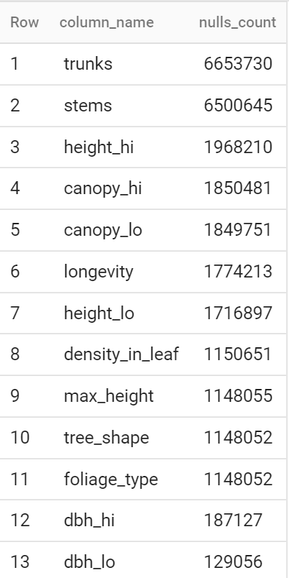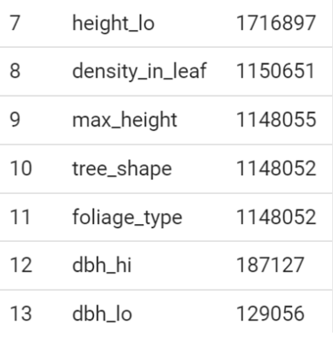

# 

# TREE HISTOGRAMS/BOXPLOTS

Lower Bound: 250

Upper Bound: 2,500

Figure 1

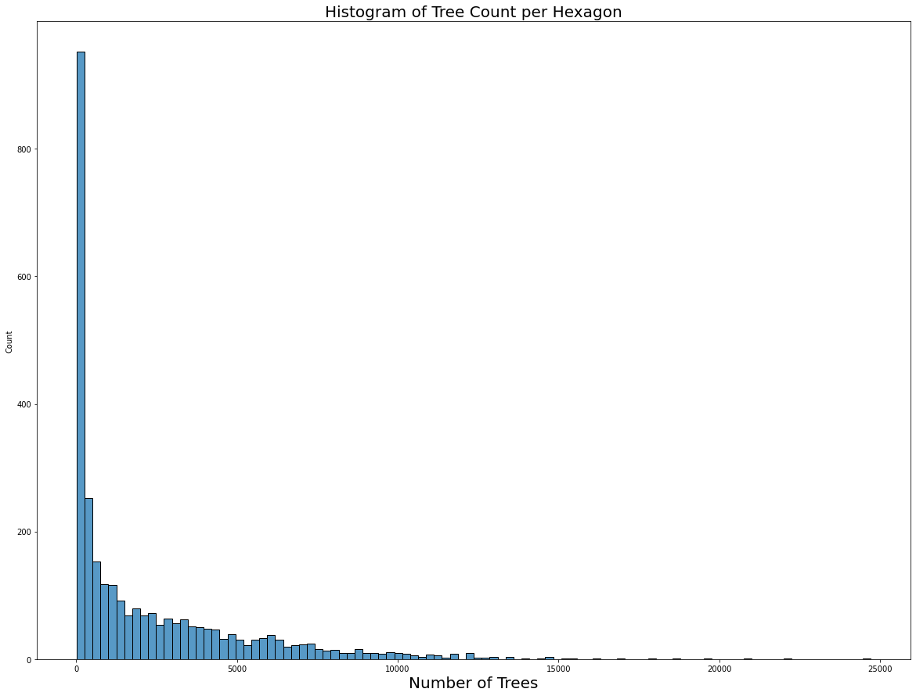

Figure 2

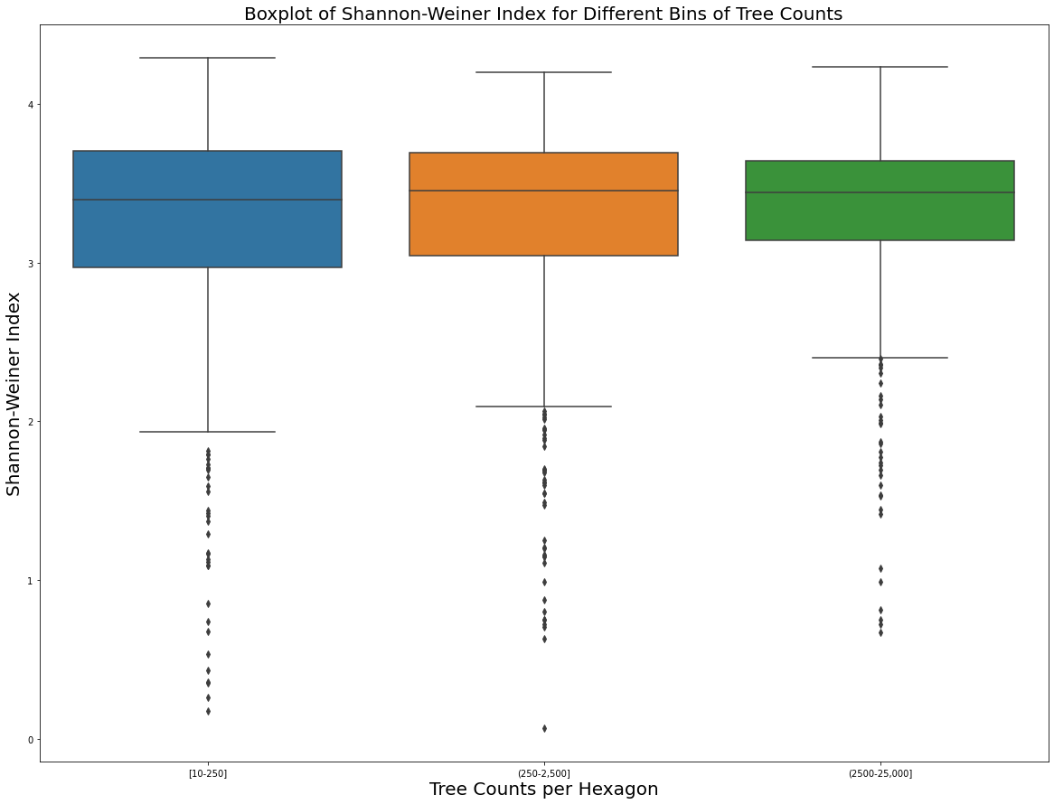

Shannon-Wiener index centered around the same values but variability decreases as the Tree counts increase.

Figure 3

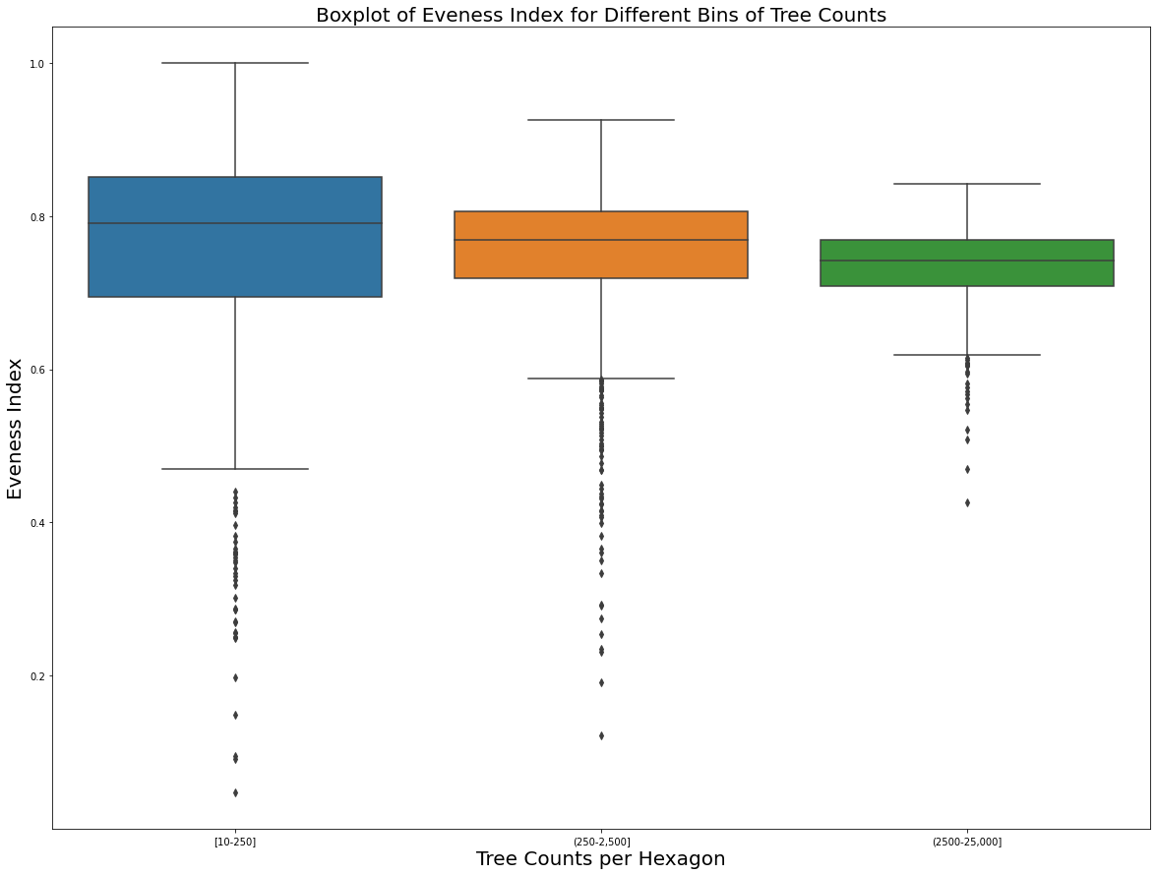

Evenness has a similar trend to Shannon-Wiener but more extreme. Similar centers across bins but variability decreases as Tree counts increase.

Figure 4

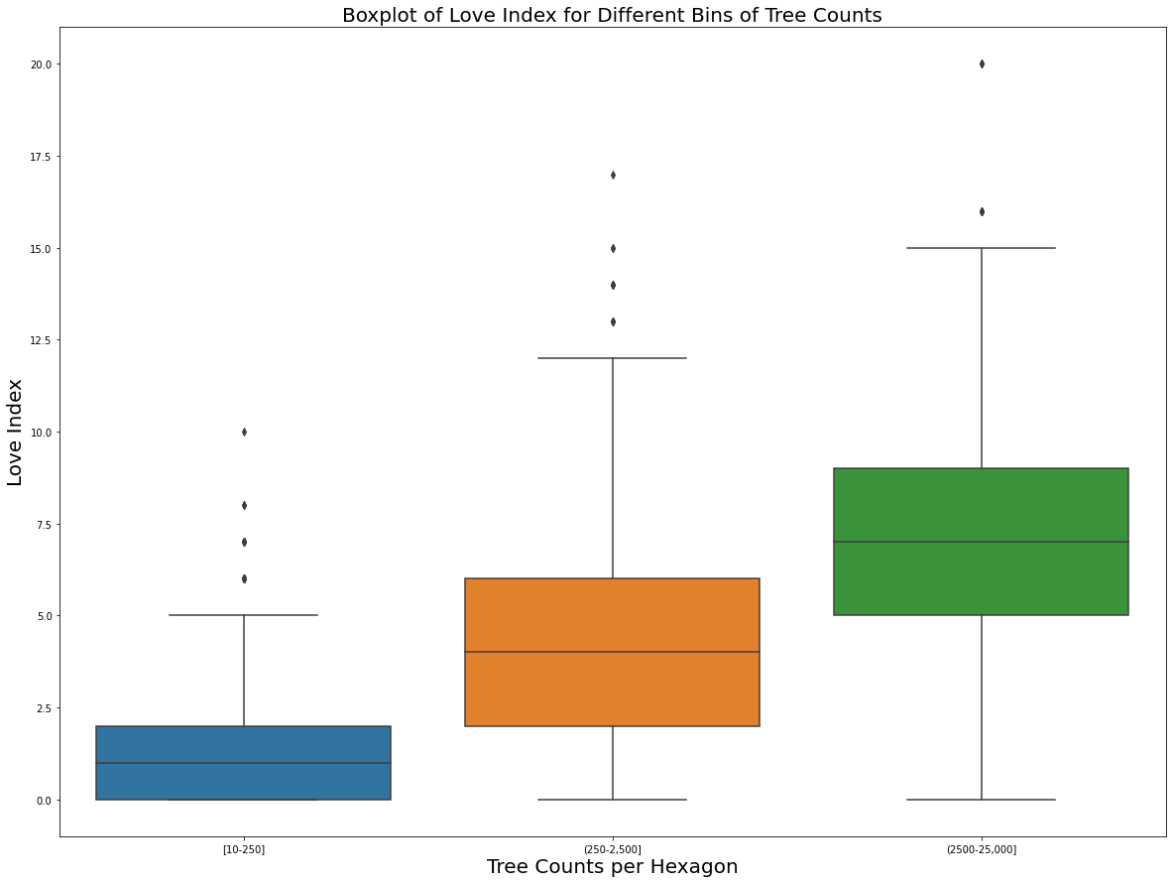

Average TD-50 Index increases as the Tree Count bins increase. Intuitively makes sense - as you have more units in your population, should expect more species to take up 50% of the population.

# BIRD HISTOGRAMS/BOXPLOTS

Grid 12255 (Sacramento-ish) has about 156k bird observations, having a sum of individual counts with ~31million (Extreme Outlier)

There are 8 other hexagons with more than 10million bird observations

Heavily skewed histogram, so used logs

Lower Bound: e^6.18399593 ~ 485

Upper Bound: e^8.24338941 ~3,803

Figure 5

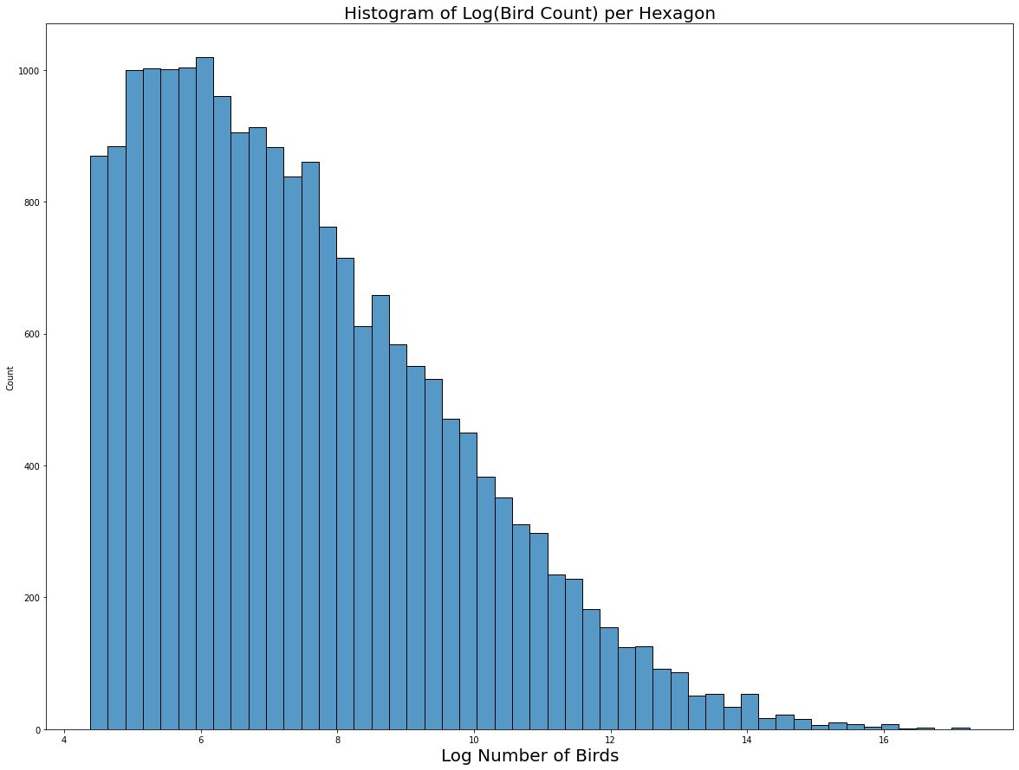

Figure 6

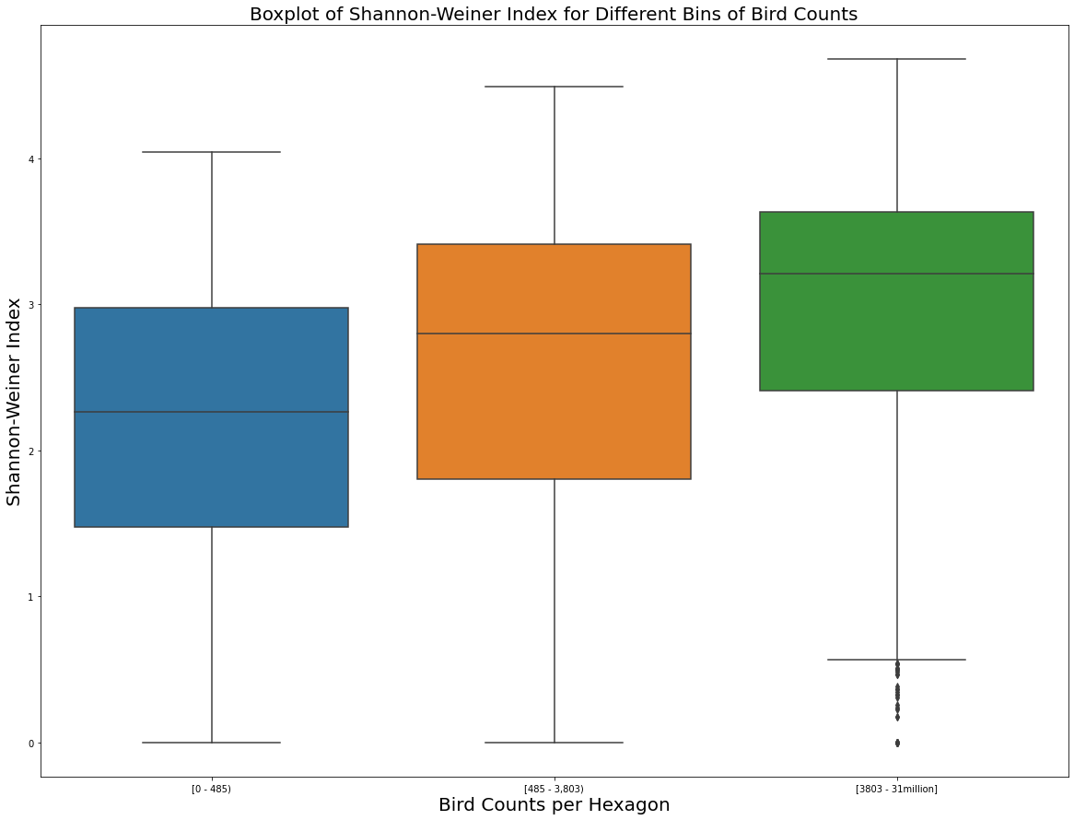

Similar variability across bins but average Shannon-Wiener index increases as the Bird bins increase.

Figure 7

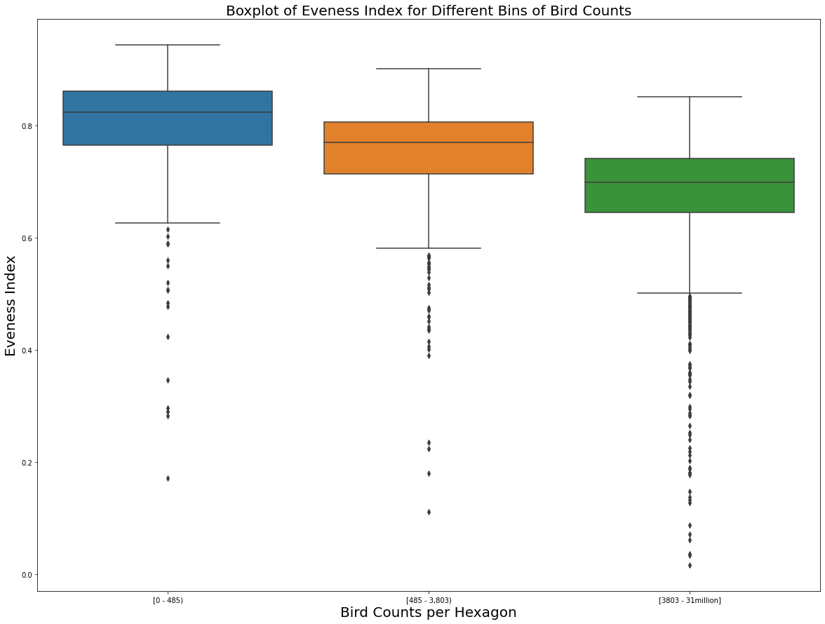

Similar variability across bins but average Evenness decreases as the bins increase.

Figure 8

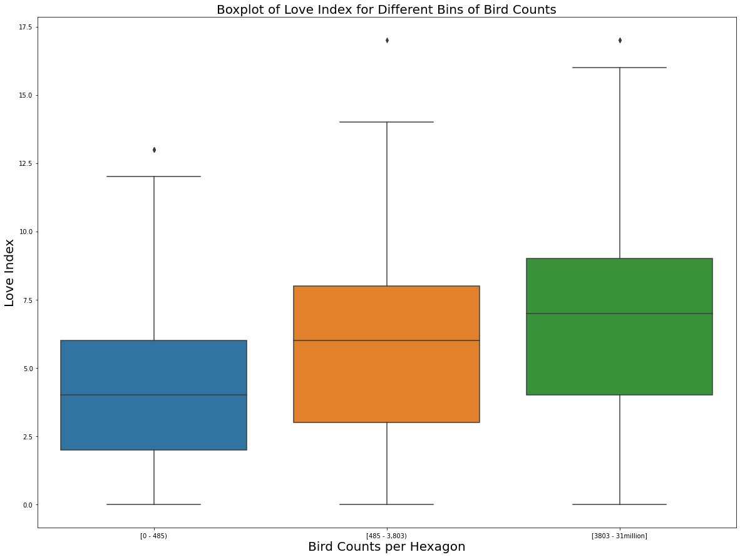

Same trend as TD-50 for Trees, average Index increases as the bins increase

# POPULATION HISTOGRAM

Figure 9

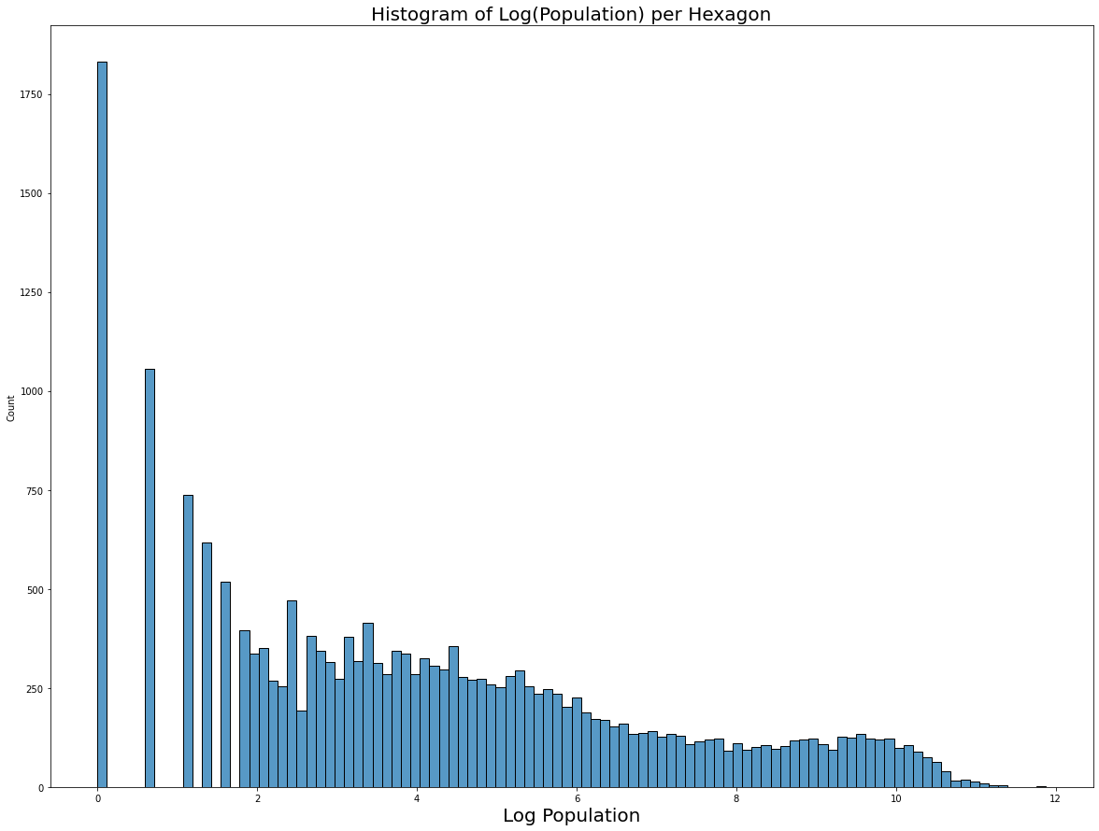

Lower Bound: e^2.61237498 ~ 13.63

Upper Bound: e^5.22474996 ~ 185.81

Figure 10

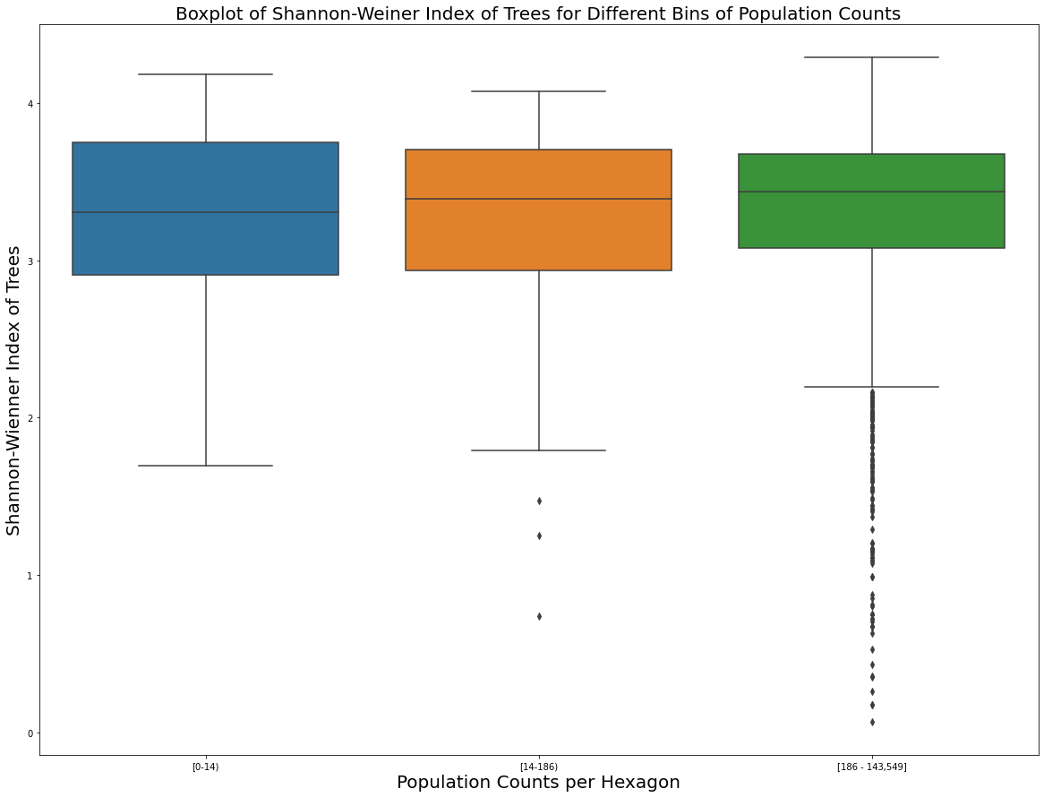

Figure 11

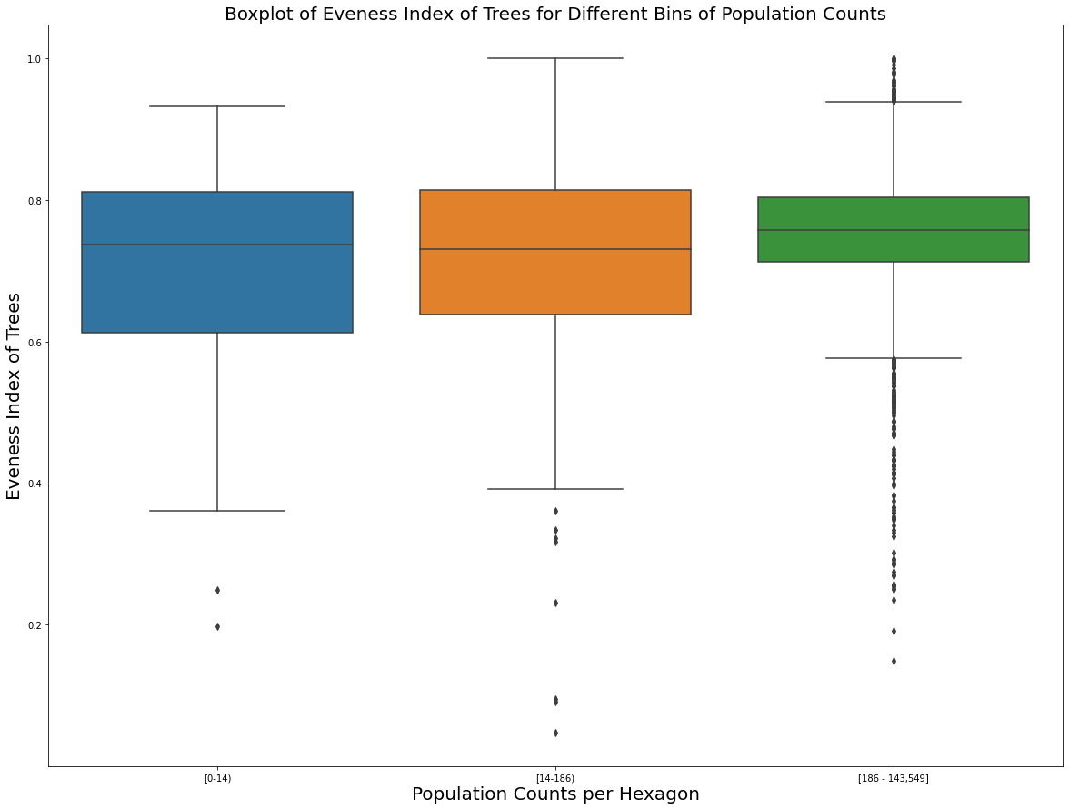

Figure 12

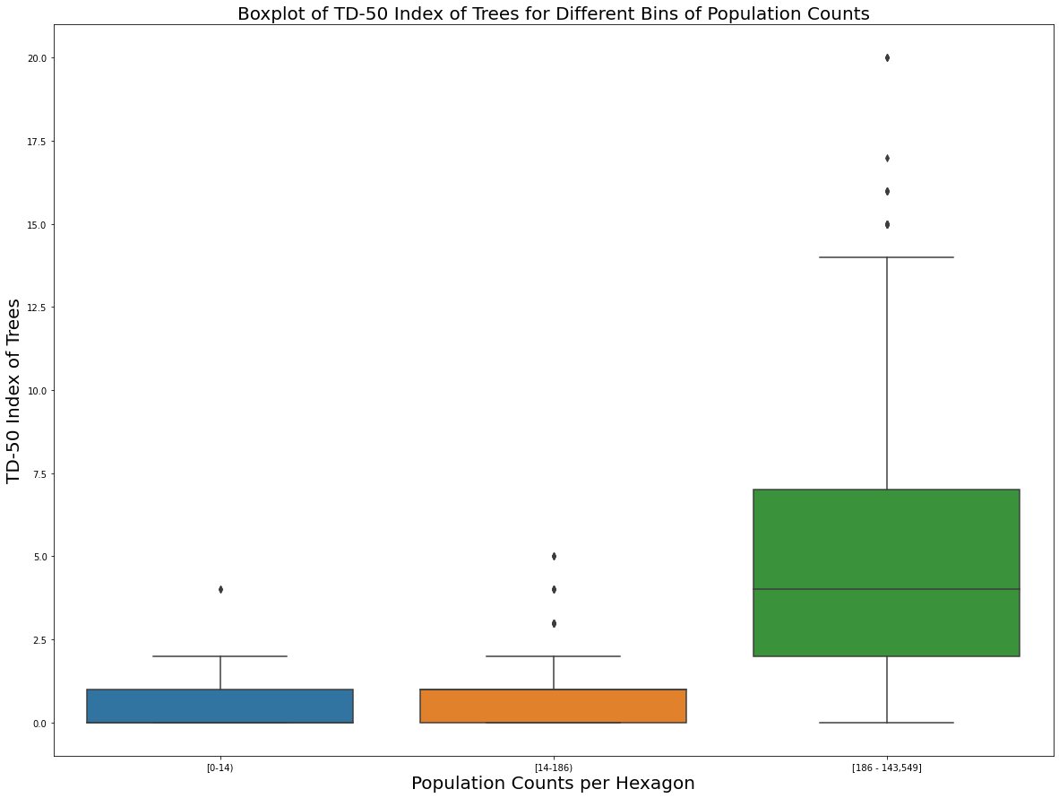

Updated population plot. For this plot, I set all 0 counts to the tan background

Figure 13

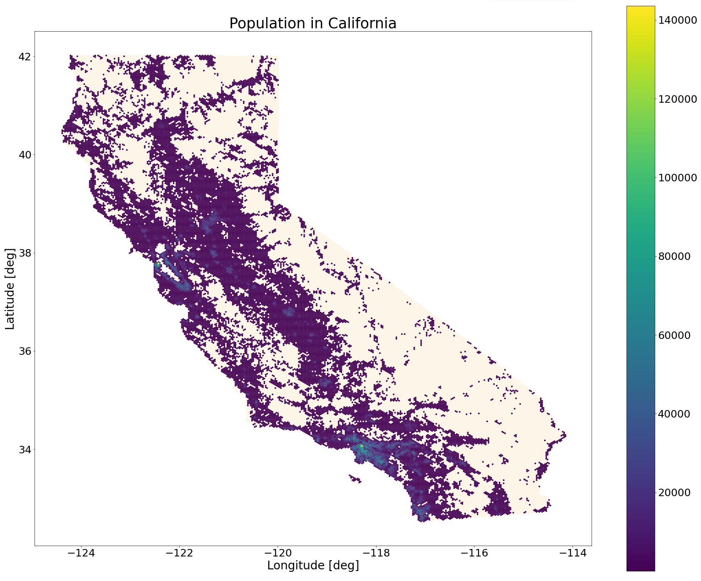

# BETA DIVERSITY

Wrote code to find the 6 neighbors of each hexagon so that we can start calculating beta diversity measures. The corresponding dataset has been uploaded to bigquery as ca-hexagons-neighbors

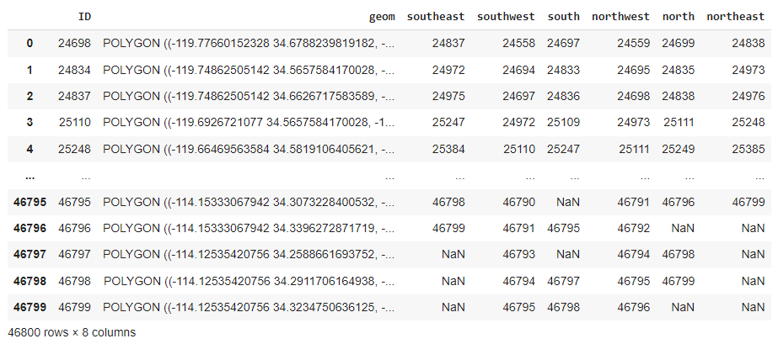

Figure 14

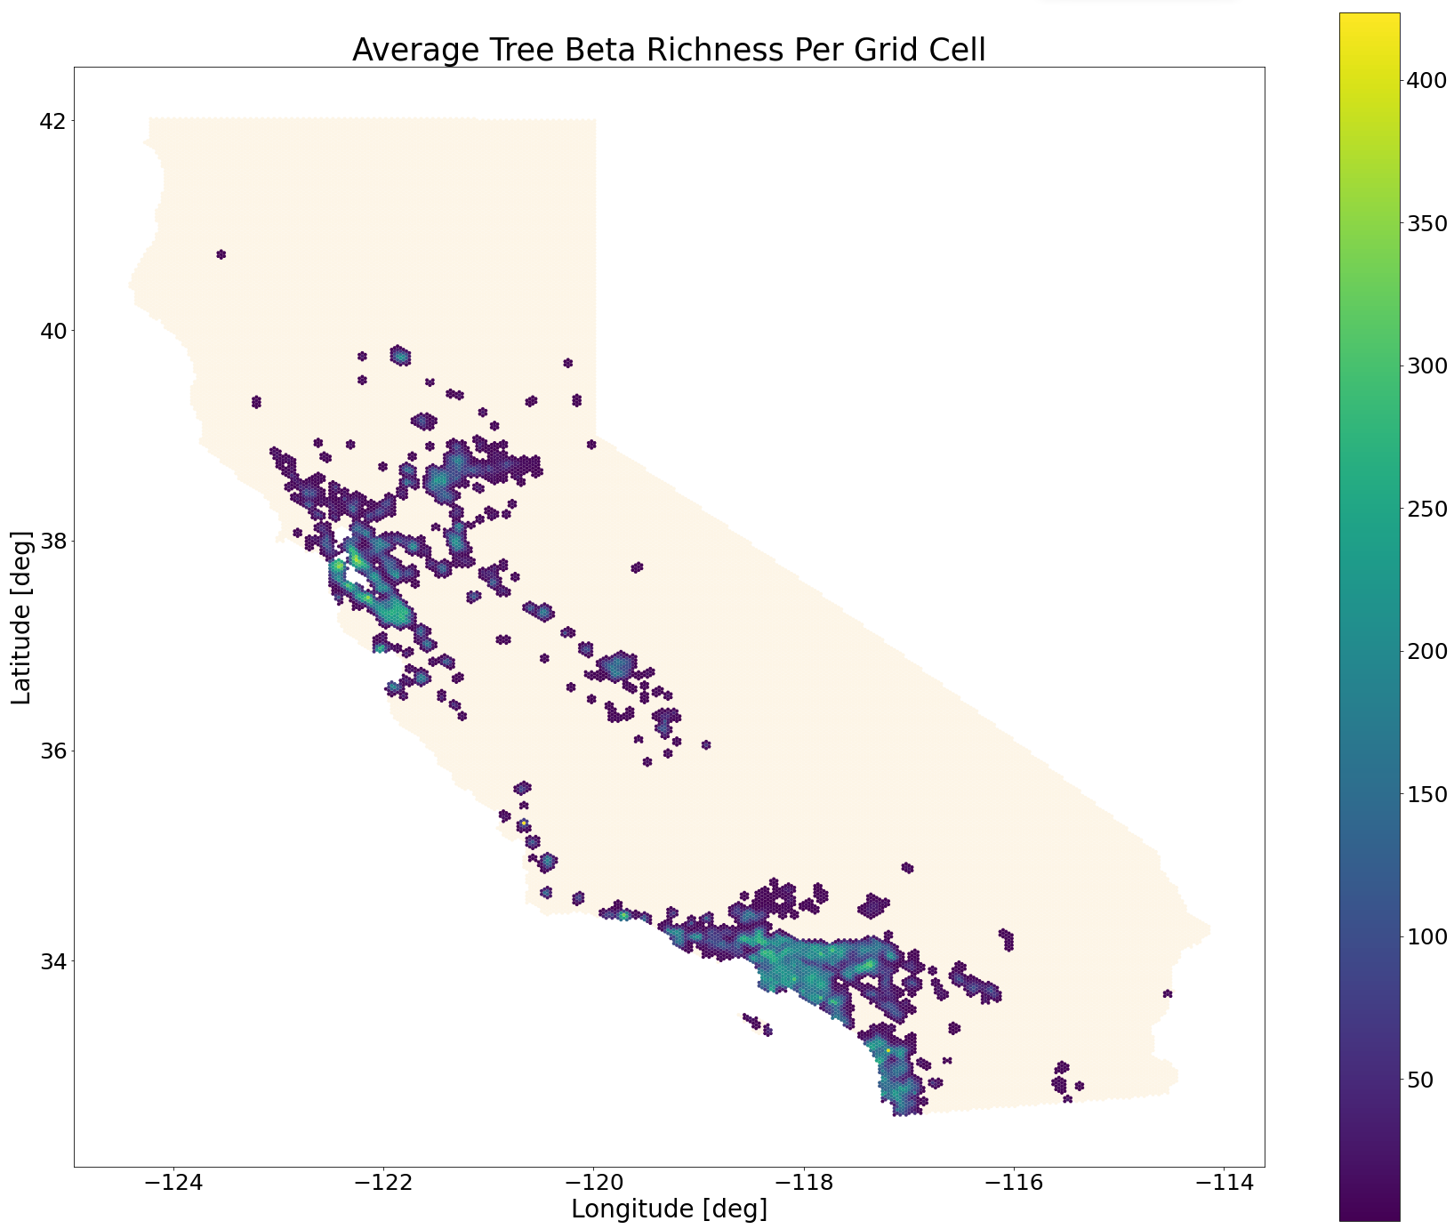

Figure 15

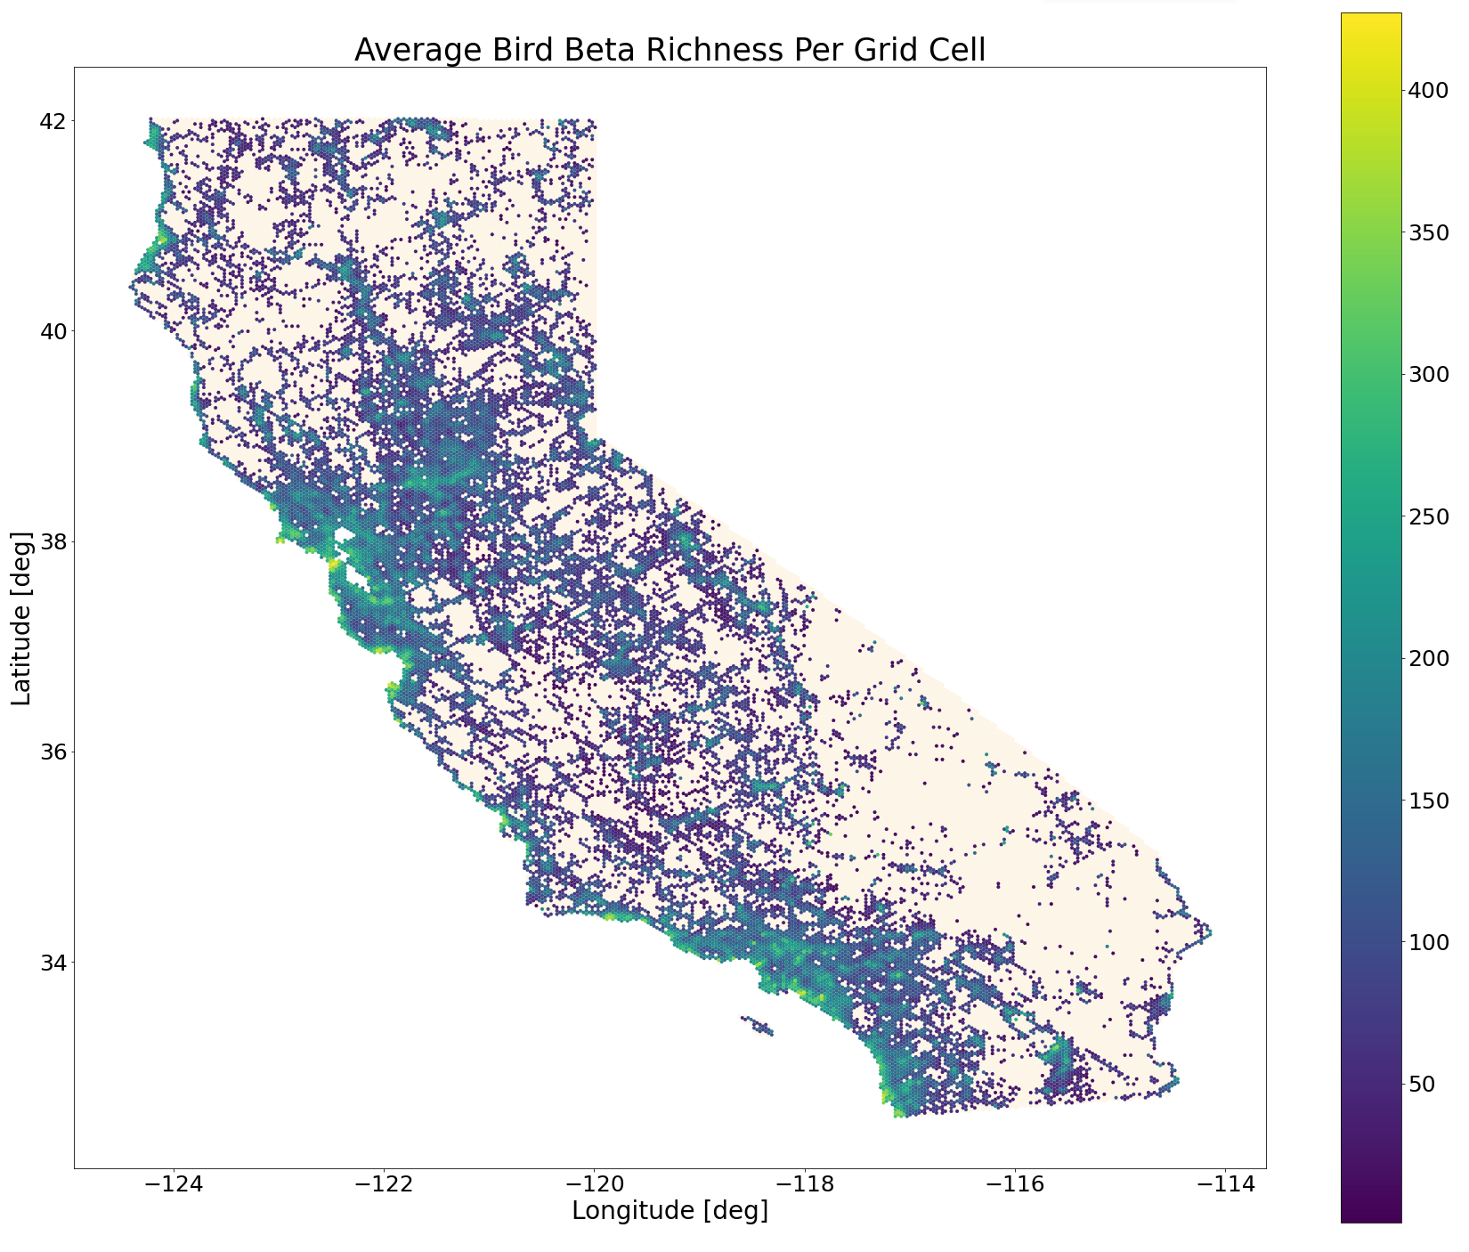

Figure 16

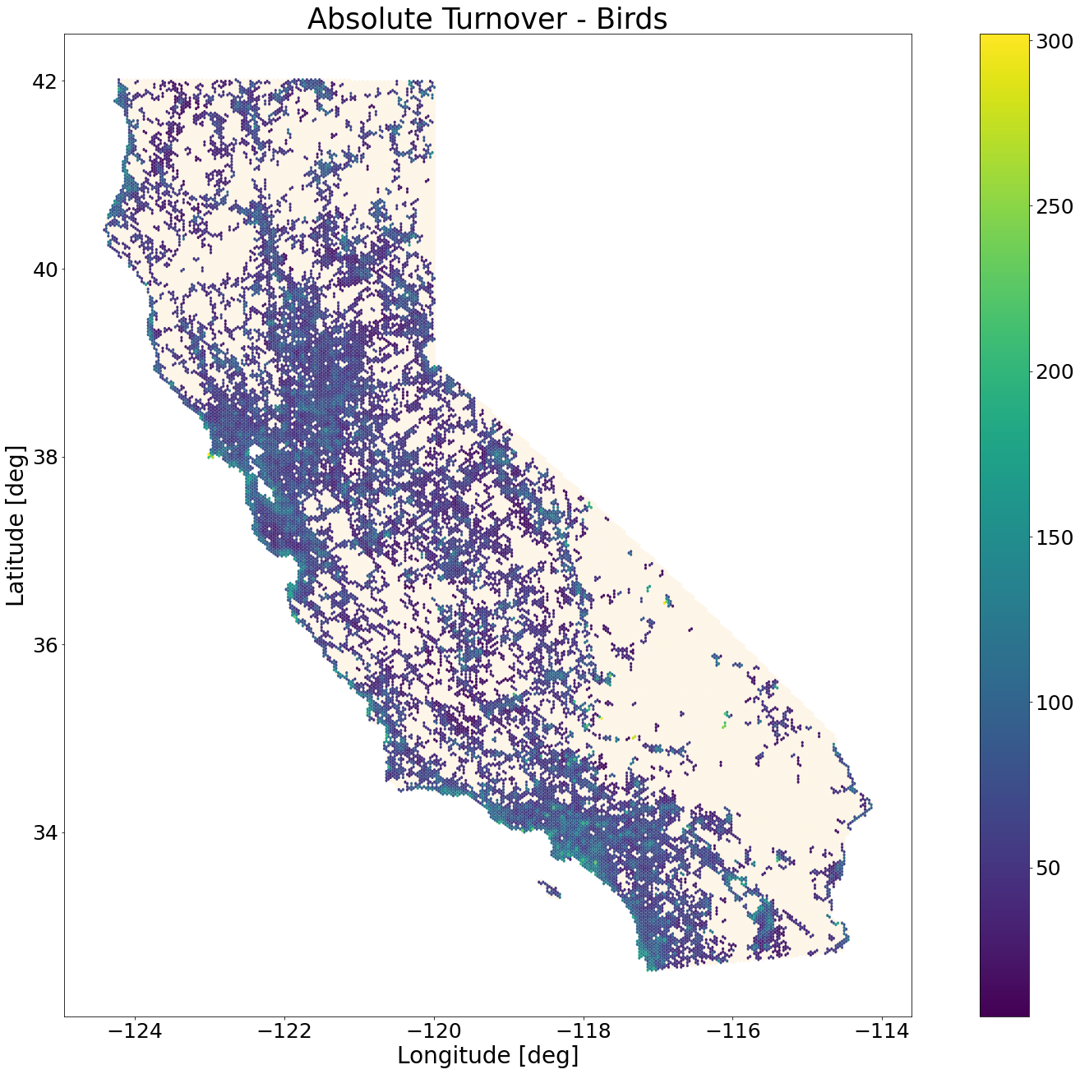

Figure 17

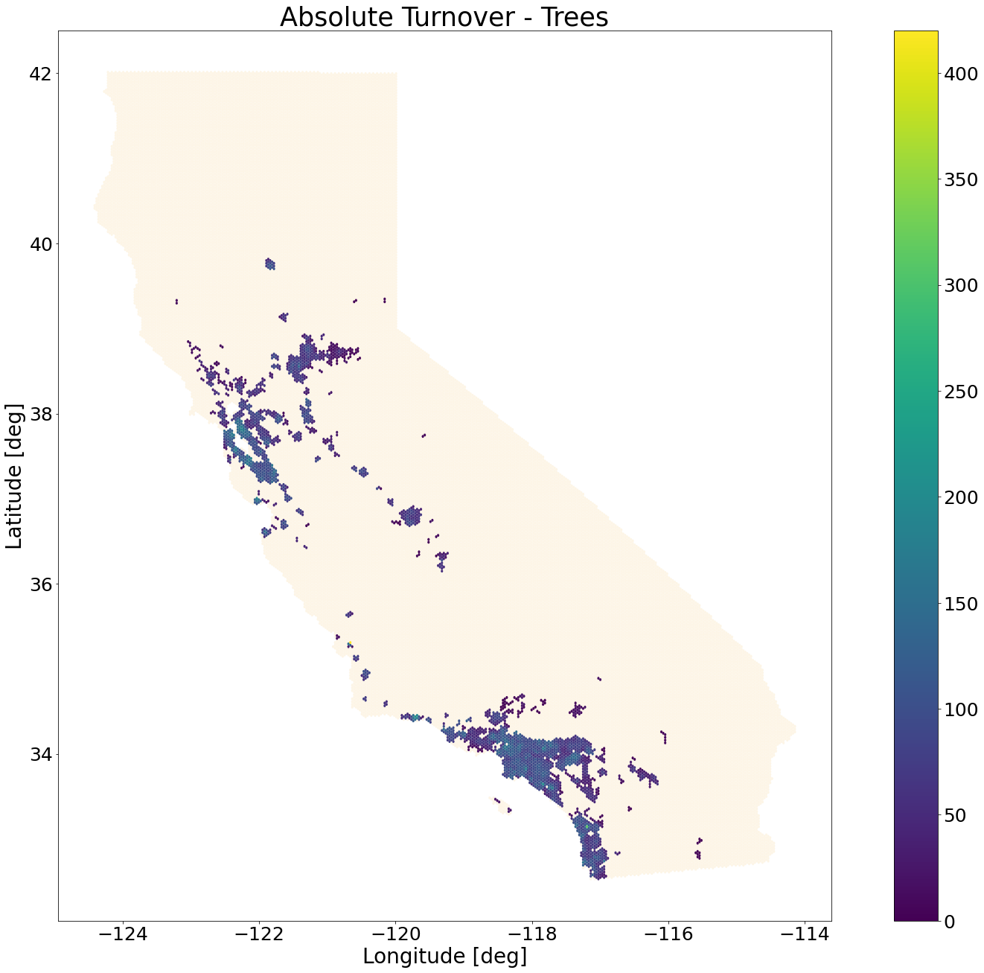

# NEW THRESHOLDS & Measure

New Thresholds with justifications:

* “limited availability of samples—a situation often faced in studies on rare or elusive animals—Ns = 5 samples;
* a minimum acceptable number of samples as suggested by Pruett & Winker (2008) commonly occurring in population genetics studies—Ns = 20 samples;
* optimal sampling, according to Bashalkhanov, Pandey & Rajora (2009)—Ns = 80 samples.
* -a very large sample with presumably low sampling error—Ns = 200 samples.

Switch the threshold to 20 for trees, to only choose hexagons with a “min acceptable number” of samples.

Choose 80 for birds, since it is going to be our response variable. Therefore we want it to be “optimally” sampled

A mixture of fruit-producing trees and nectar-producing trees can benefit both frugivorous bird species and pollinators feeding on nectar. For example, Ceiba pubiflora trees can provide nectar for at least 25 local bird species in the city of Sao Paulo in Brazil (Silva, 2018). Similarly, existence of species with different flowering or fruiting seasons can provide more complementary resources for bees, birds, and beetles, and enhance ecosystem stability (Salisbury et al., 2015).

<https://besjournals.onlinelibrary.wiley.com/doi/10.1111/1365-2745.13598>

In contrast, cities dominated by tree monocultures support few animal species, and are likely to suffer from pests or diseases specific to certain species (Cowett& Bassuk, 2020). In practice, the proportion of the most abundant species forms a reasonable predictor of urban tree diversity (Kendal et al., 2014). Ideally, a single species should not exceed 10%-20% of the total number of individuals to enhance ecosystem resilience (Santamour,1990; Kendal et al., 2014).

Biodiversity-friendly cities should also have a high proportion of native trees because these are known foraging resources for native animals, such as birds (Paker et al., 2014; Narango et al., 2018; Wood & Esaian, 2020), insects (Southwood, 1961; Helden et al., 2012) and bees (Threlfall et al., 2015). In Canberra, streets with more native eucalyptus trees had significantly higher bird species richness (Ikinmet al., 2013). Similarly, other studies conducted in USA and Azores islands found that native trees supported significantly greater abundance, diversity, biomass of butterflies and birds than non-native trees (Burghardt et al., 2009; Burghardt et al., 2010; Heleno et al., 2009).

Figure 18

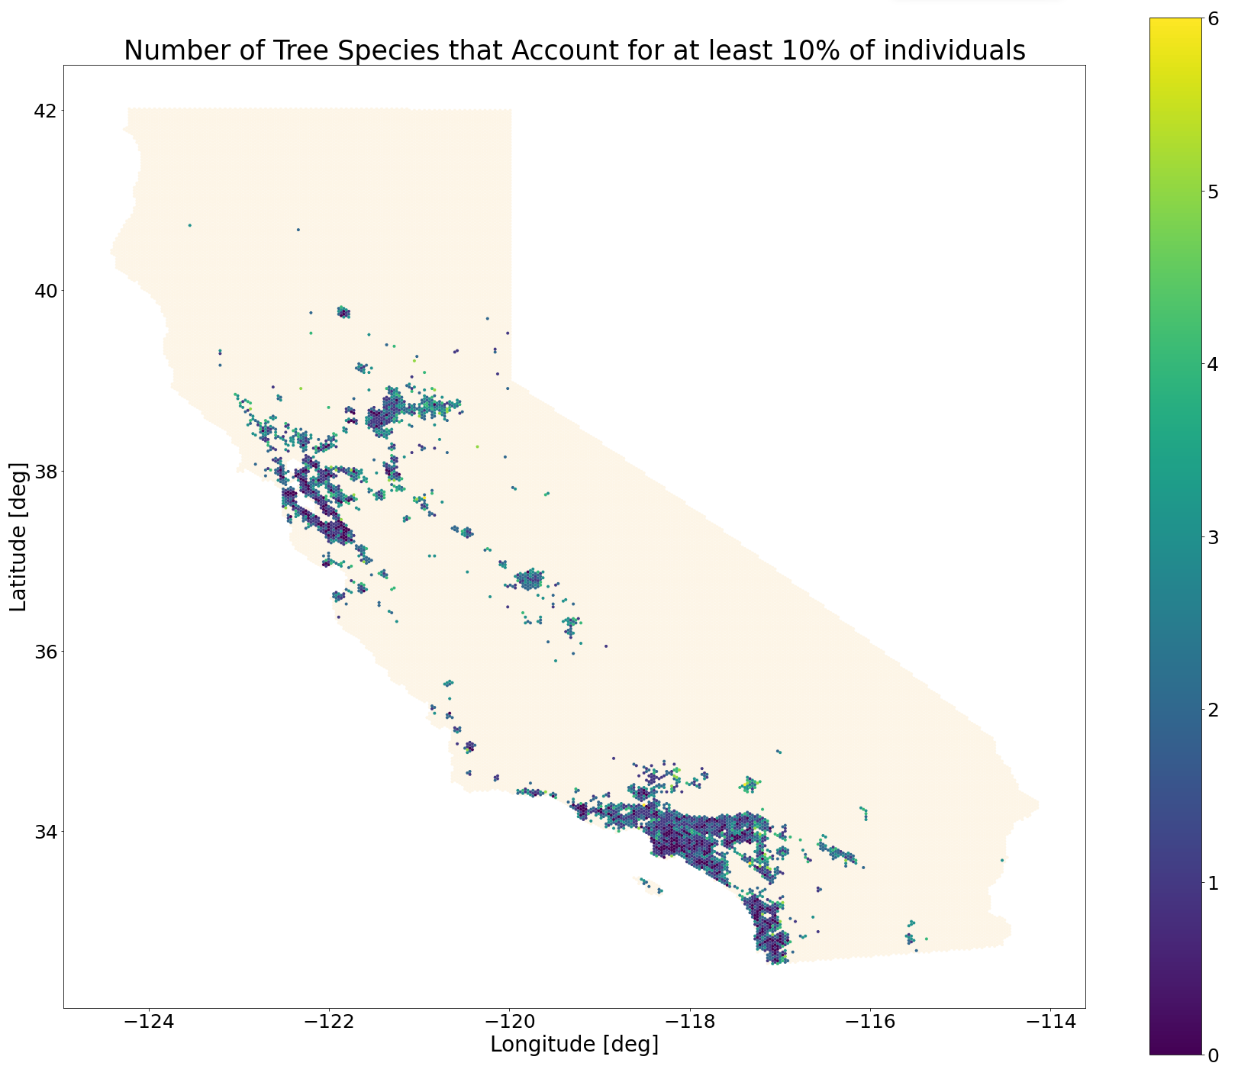

Figure 19

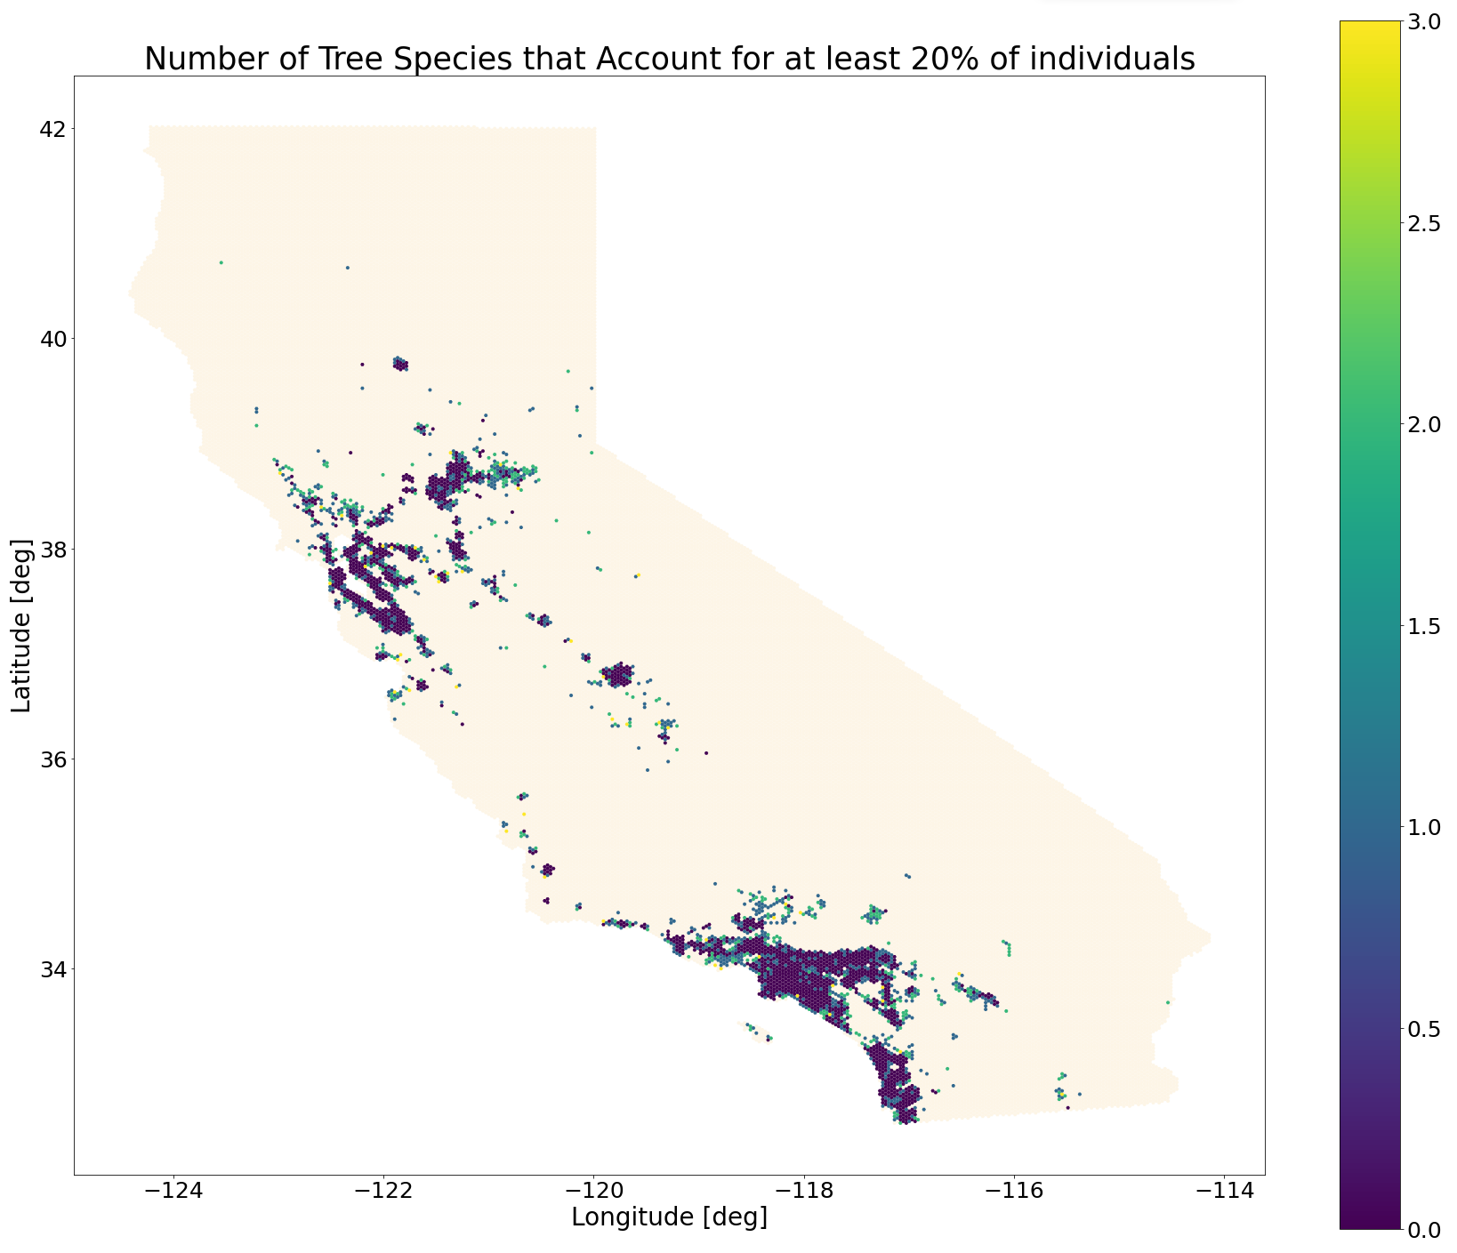

# MIXED DIVERSITY SCATTER PLOTS

Figure 20

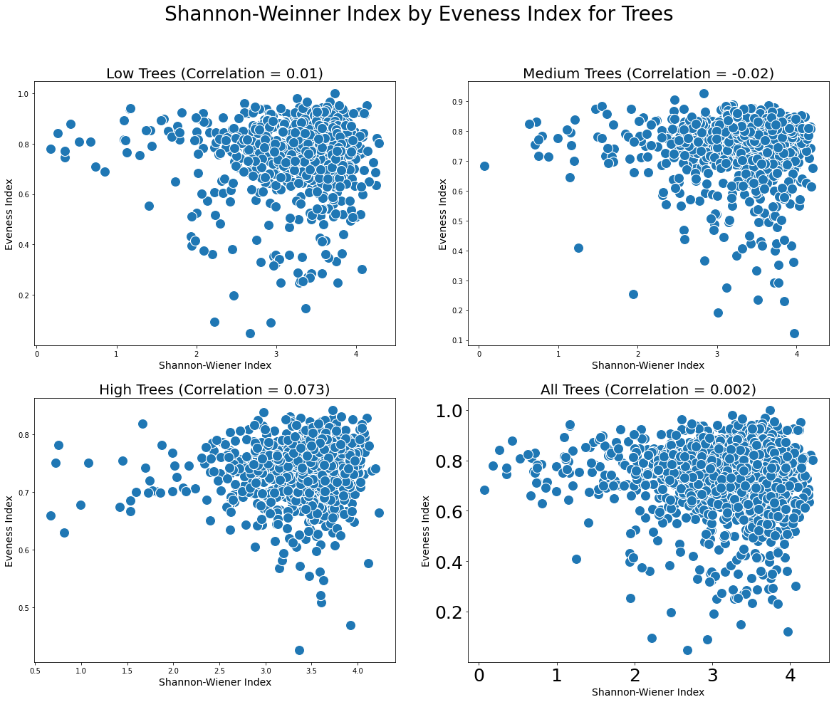

Figure 21

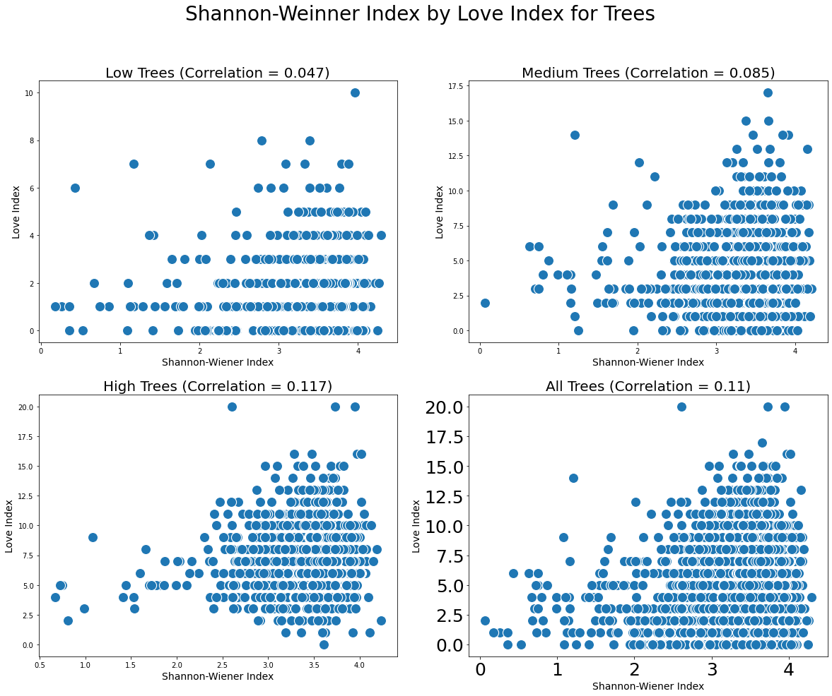

Figure 22

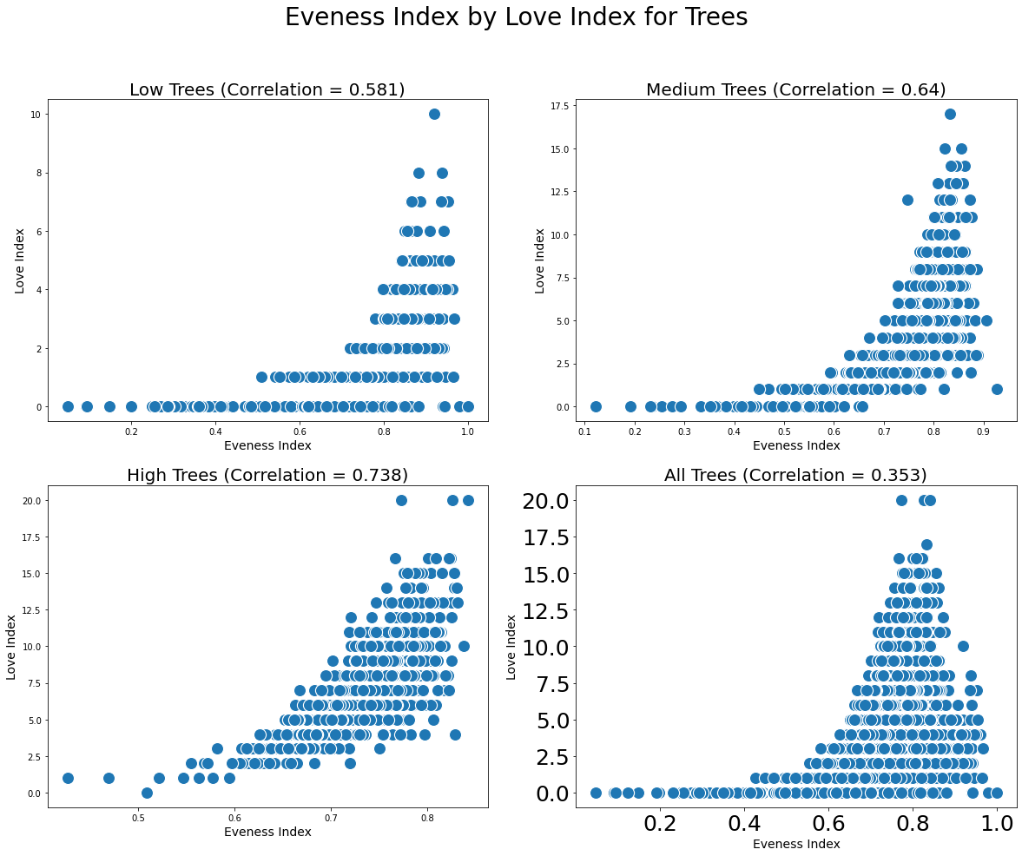

Figure 23

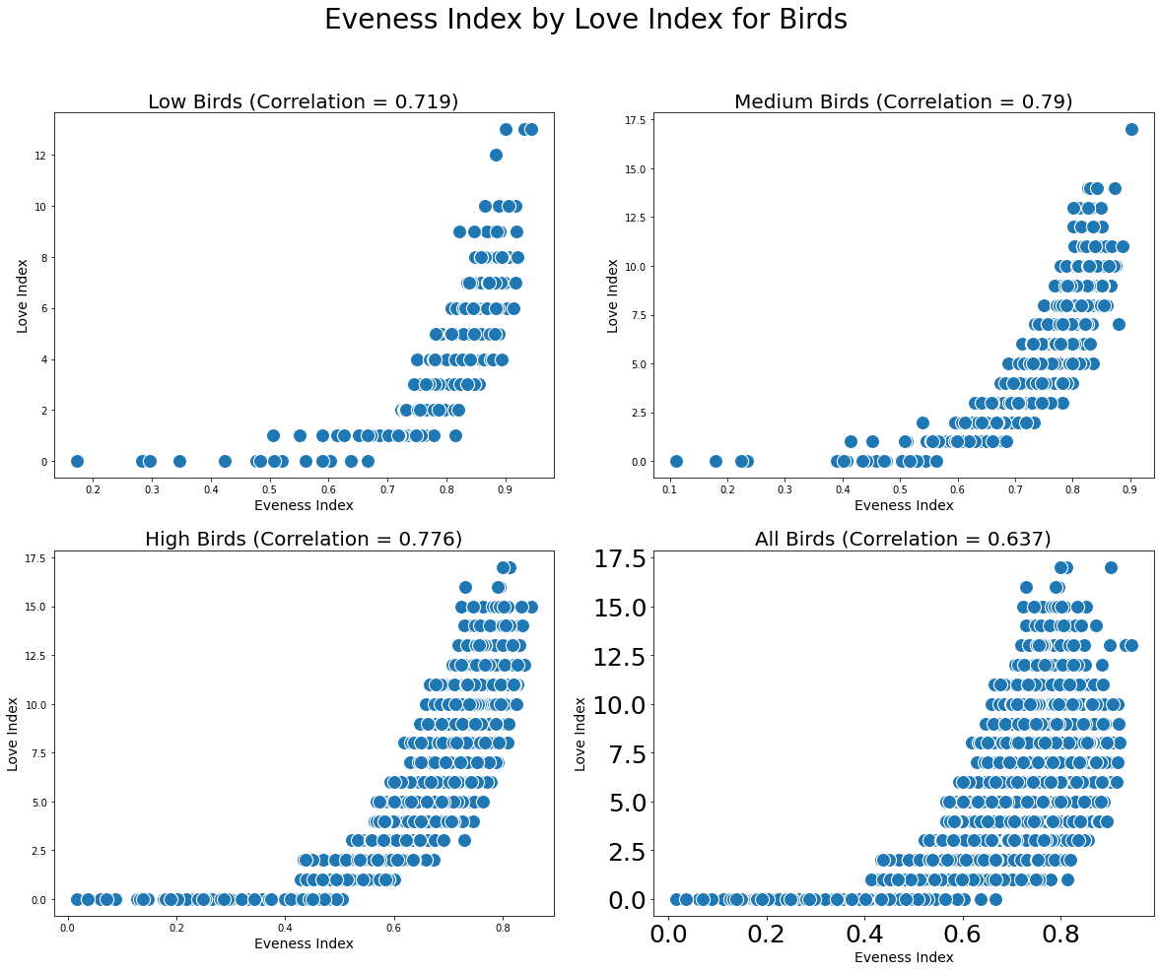

Figure 24

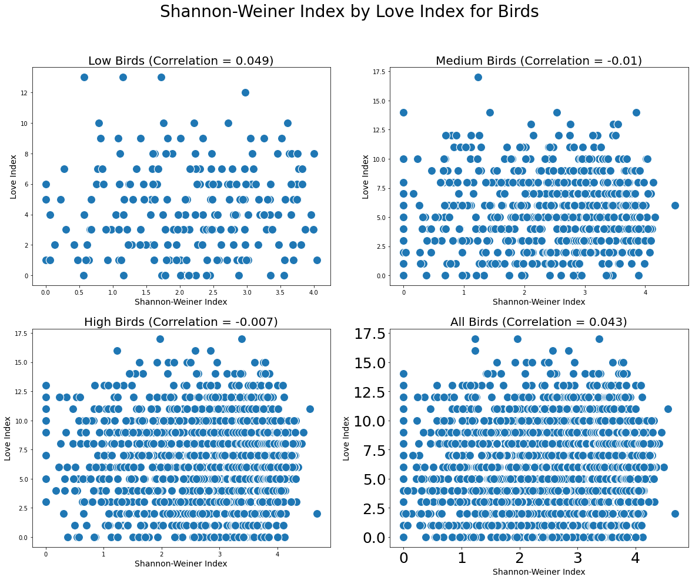

Figure 25

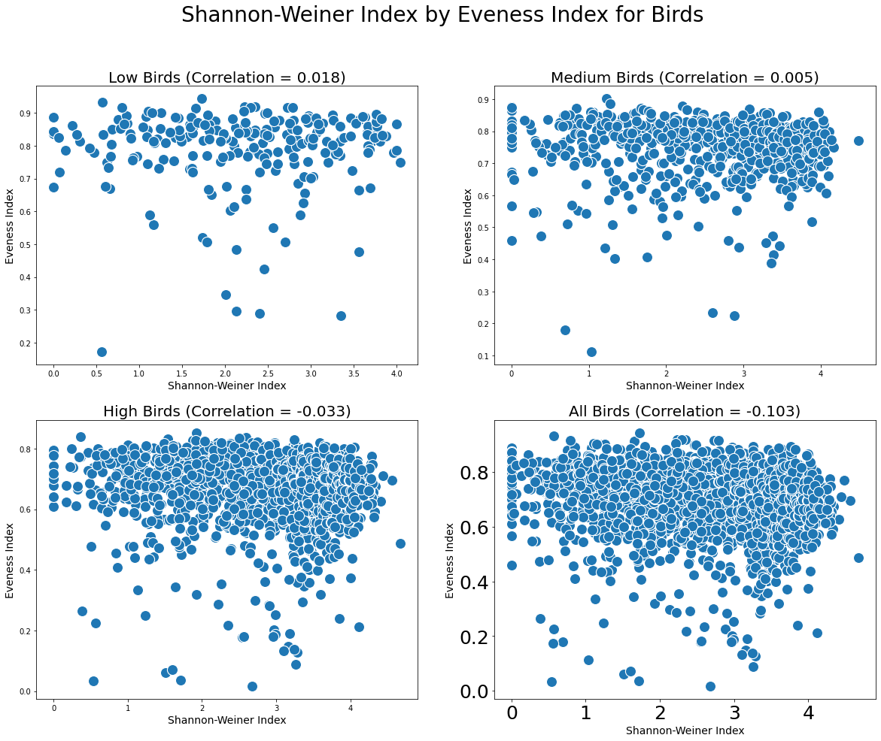

## 

## BIRDS BY TREES BY POPULATION BINS

Figure 26

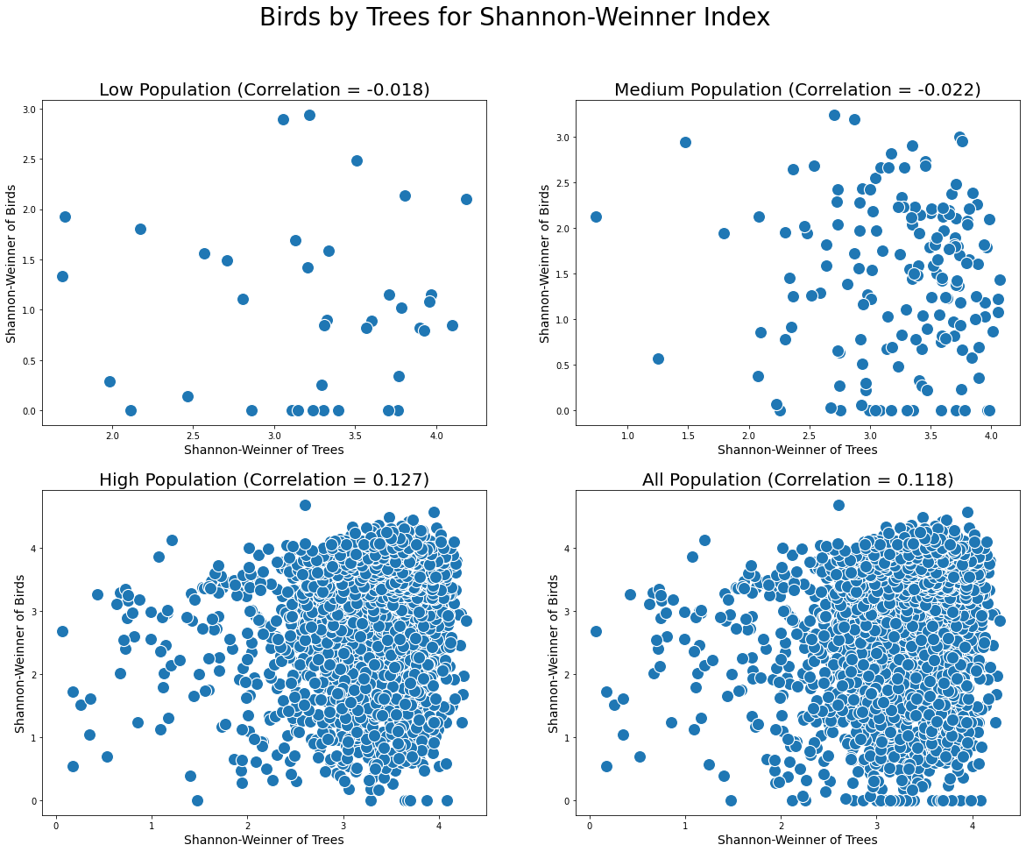

Figure 27

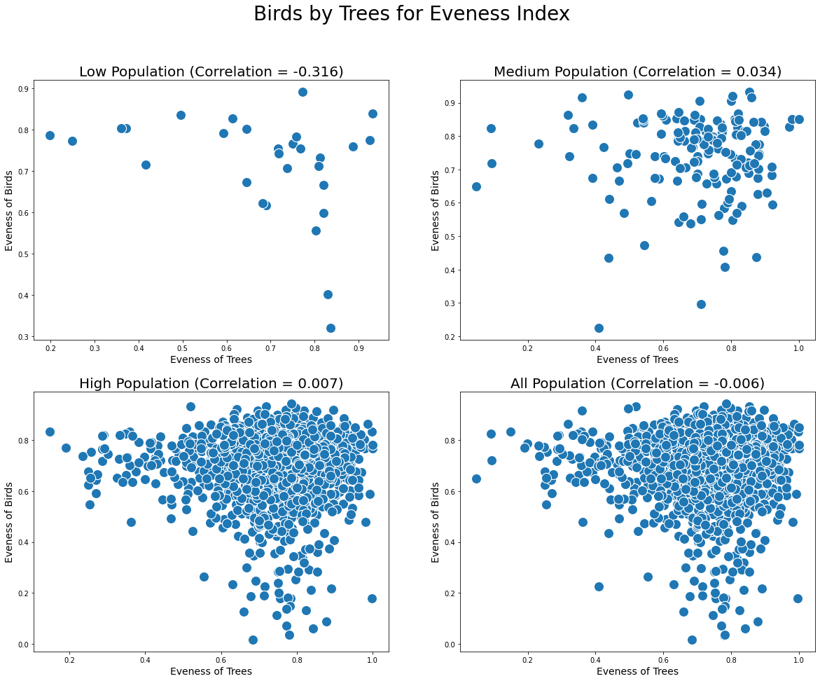

Figure 28

